Project Design Phase-II
Data Flow Diagram & User Stories

Date | 20 February 2026
Team ID | LTVIP2026TMIDS67086
Project Name | weather-based prediction of wind turbine energy output: a next-generation approach to renewable energy management
Maximum Marks

Data Flow Diagrams:
The DFD for the Wind Energy Prediction Web Application illustrates how user inputs and real-time weather data flow through the system, are processed by the backend and machine learning model, and return predicted energy output to the user.
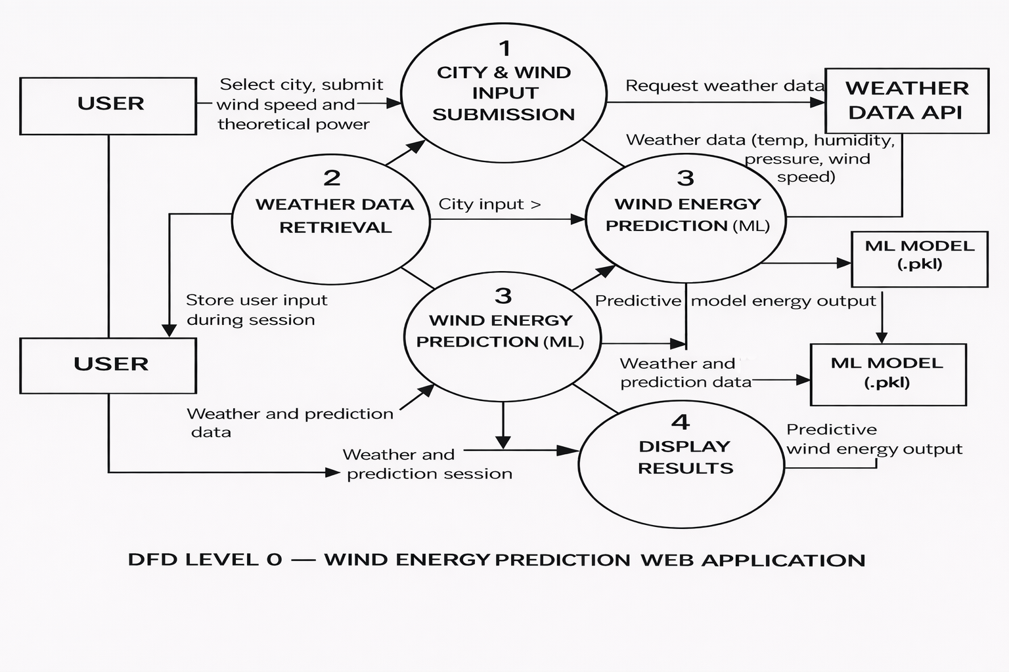

User Stories – Wind Energy Prediction Web Application
User Type | Functional Requirement (Epic) | User Story | Acceptance Criteria | Priority | Release
User | Weather Retrieval | As a user, I can select a city to view real-time weather data. | Weather details are displayed correctly. | High | Sprint-1
User | Energy Prediction | As a user, I can enter wind speed and theoretical power to predict energy output. | Predicted energy value is shown. | High | Sprint-1
User | Result Display | As a user, I can see both weather and prediction results on the same page. | Both results remain visible simultaneously. | Medium | Sprint-1
User | Input Validation | As a user, I receive an error message for invalid inputs. | Proper error message is displayed. | Medium | Sprint-1
Admin (System) | API Integration | As a system admin, I can configure the weather API securely. | API key is stored securely in .env file. | High | Sprint-1

